**TITLE OF THE EXTENDED ABSTRACT – OPTIMIZING …**

**Jordan Denev* and Co Authors\*\***

*\*Karlsruhe Institute of Technology, Steinbuch Centre for Computing*

*\*\*Uni #2, Institute … (if different)*

**Abstract (optional)**

This document should contain 1 to 4 pages. This abstract (optional) should be no longer than 6 lines.

**1. Introduction**

The following sample sections are only a suggestion – please feel free to name them as you wish, include/remove some sub-sections etc. Optionally, you may include also an Abstract.

**2. Description or Method or Numerical Issues**

Paragraph 1 beginns here.

Paragraph 2 beginns here without an indent. Please leave 1 free line after the paragraph.

**3. Results and Discussion**

Here we present some results, including figures. Results should be scientific, but please, include also information on CPU-usage, typical core numbers, duration and experience you would like to share with other users.

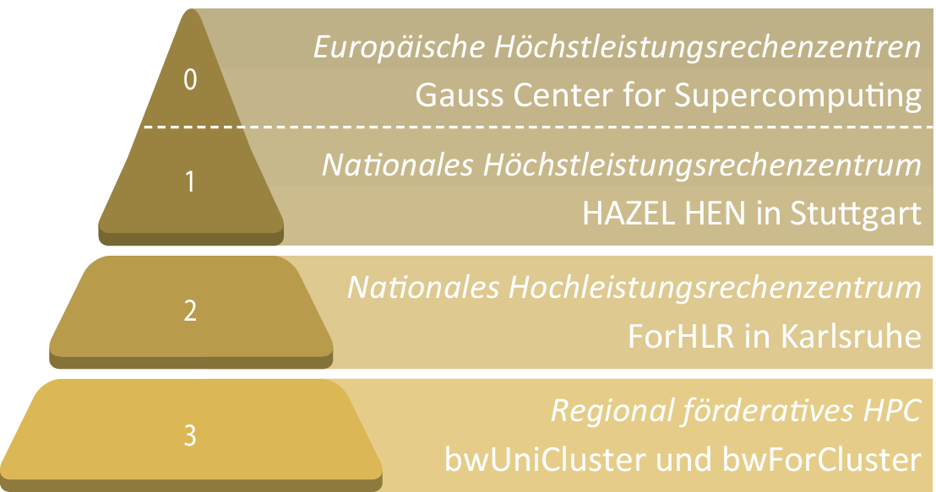

**Fig. 1** Here the caption-text is given.

|  |  |  |  |
| --- | --- | --- | --- |
| **Simulation** | **CPU-time, h** | **Number of cores** | **bwHPC Cluster** |
| Run 1 | 10000 | 128 | JUSTUS |
| Run 2 | … |  |  |

**Table 1.** Tables may look like this one

**4. Conclusions**

Conclude the findings.

**5. Acknowledgements**

This chapter is optional.

**References**

[1] Peters, N.: Turbulent Combustion. Cambridge Monographs on Mechanics. Cambridge University Press (2000)

[2] Soika, A., Dinkelacker, F., Leipertz, A.: Pressure influence on the flame front curvature of turbulent premixed flames: comparison between experiment and theory. Combust. Flame 132 (2003) 451–462

[3] Vukadinovic, V, Habisreuther, P, Zarzalis, N, Suntz, R.: Influence of Pressure on Markstein Number Effects in Turbulent Flame Front Propagation. Proc. ASME Turbo Expo (2013) GT2013-94307